PRACTICUM REPORT 13TH WEEK COMPUTER NETWORKING
Computer Networking Design and Implementation for School/Office Infrastructure


Lecturer:
Dimas Novian Aditia Syahputra, S. Tr. T., M. Tr. T.
Prepared by:
Name: Aisyah Currents
NIM (Student id): 25091397108
Class: International

UNIVERSITAS NEGERI SURABAYA
FACULTY OF VOCATION
INFORMATICS MANAGEMENT STUDY PROGRAM
YEAR 2025

TABLE OF CONTENTS

TABLE OF CONTENTS 1
CHAPTER I 2
INTRODUCTION 2
1.1. Background 2
1.2. Objective 2
CHAPTER II 4
THEORETICAL BASIS 4
2.1. Computer Network Concepts 4
2.2. Case Study Scenarios 4
2.2.1. School Network Design Scenario 4
2.2.2. Office Network Design Scenario 5
CHAPTER III 6
METHODOLOGY 6
3.1. Tools and Materials 6
3.2. Procedure 6
CHAPTER IV 11
CLOSING 11
4.1. Conclusion 11

CHAPTER I

INTRODUCTION

Background
The rapid advancement of information and communication technology has made computer networks an essential component of modern educational institutions and office environments. Schools and workplaces increasingly rely on digital systems to support daily operations, including data management, communication, online learning, administrative tasks, and access to shared resources. Without a well-designed and reliable network, these activities can be disrupted, leading to decreased productivity and inefficiencies in workflow.
In many cases, existing network infrastructures are poorly structured, lack proper segmentation, or do not meet current security standards. This results in issues such as slow connectivity, limited wireless coverage, difficulties in resource sharing, and vulnerability to cyber threats. Therefore, a systematic approach to designing and planning a computer network is necessary to ensure optimal performance, scalability, and security.
Designing a computer network for a school or office involves several key processes, such as identifying user needs, selecting appropriate network devices, determining IP addressing schemes, configuring routers and switches, implementing wireless access points, and establishing security policies. A well-planned network not only improves communication and collaboration but also enhances operational efficiency and supports future technological growth.
Thus, this practicum aims to design and plan a computer network infrastructure that is reliable, secure, and capable of supporting daily academic or office activities. By developing a structured network design, institutions can provide better digital services, minimize downtime, and maintain a stable technological environment.

Objective
The objectives of this practicum are as follows:
- To understand and master the fundamental concepts of computer networks within the selected case study, whether in a school or office environment.
- To analyze the network requirements based on the given scenario, ensuring that the design aligns with the operational needs of the institution.
- To demonstrate competence in network topology comprehension, including star, bus, ring, and mesh topologies, and to determine which structure is most suitable for the chosen environment.
- To identify and select appropriate network devices, such as switches, routers, access points, and various types of network cables, according to the technical and functional requirements.
- To design an effective network layout that supports connectivity, scalability, and performance based on the user and device distribution within the building.
- To calculate estimated costs and determine device specifications, ensuring that the proposed network design is both feasible and efficient from a financial perspective.

CHAPTER II

THEORETICAL BASIS

2.1. Computer Network Concepts
A computer network is a system that connects multiple devices so they can share data, resources, and services. Networks enable communication between computers, printers, servers, and other digital equipment within a school or office environment. Key characteristics of a computer network include data transmission, protocols, addressing, and network services. Networks can be classified based on their coverage area, such as Local Area Network (LAN), Metropolitan Area Network (MAN), and Wide Area Network (WAN).

2.2. Case Study Scenarios
This practicum is based on two main case study scenarios that represent common implementations of computer networks in educational and office environments. These scenarios are used as the basis for applying network concepts, topology selection, device planning, and cost estimation.

2.2.1. School Network Design Scenario
The network is designed for a school building with three floors, including:
- 10 classrooms
- 1 computer laboratory
- 1 teachers’ office
In this scenario, the network is typically structured using a star topology with hierarchical layers:
- A core/distribution switch placed in a central location (such as a small server room).
- Access switches on each floor to connect classrooms, the lab, and the teachers’ office.
- Wireless Routers placed strategically on each floor to provide Wi-Fi coverage for mobile devices like smartphones.
- A router connecting the internal school network to the internet, possibly with a firewall function for security.
An appropriate IP addressing scheme and possibly VLAN segmentation can be used, for example:
- VLAN for classrooms
- VLAN for computer lab
- VLAN for teachers/administration
This ensures that the school network is organized, secure, and scalable for future growth.

2.2.2. Office Network Design Scenario
The second scenario focuses on an office environment with the following conditions:
- 20 employees (each using a PC or laptop, and possibly other devices)
- 2 servers (for example, one file server and database server)
The network is generally built using a star topology with:
- A central switch connecting all employee devices and the servers.
- A router to connect the office LAN to the internet and possibly to other branch offices or cloud services.
- Optional VLANs to separate:
  - User/employee devices
  - Server network
  - Guest network (if visitors need internet access)
In this scenario, careful planning of device specifications (such as switch port count, router performance, and server capacity) and cost estimation is important to ensure that the design remains both efficient and cost-effective.

CHAPTER III

METHODOLOGY

3.1. Tools and Materials
The tools and materials used include:
- Laptop/PC with simulation software (Cisco Packet Tracer).
- Network device specifications (data sheet).
- Worksheet for manual design.

3.2. Procedure
Before starting the practicum, we need a clear process so the network design can be done step by step. This practicum helps students understand how to analyze needs, choose a topology, select devices, and create a network design using Cisco Packet Tracer. By following these steps:
- Needs Analysis
In this practicum, the school building consists of three floors, each requiring reliable internet access, Wi-Fi coverage, and robust device connectivity to support a variety of users including teachers, students, computer lab personnel, and administrative staff. The building includes ten classrooms, one dedicated computer lab, and one teacher office, each equipped with a mix of wired and wireless endpoints. To meet operational needs, the network must provide seamless internet access, connectivity to a local server at IP address 192.168.10.2, wireless connections for smartphones, and stable wired connections for desktop PCs and laptops. Each floor is served by a wireless router that accommodates the specific device density and usage patterns of its users, ensuring both mobility and performance for educational and administrative tasks across the entire facility.
Meanwhile, the office environment is designed to support 20 employees along with essential administrative and communication services. The network includes two main working areas, each requiring stable internet access, wired PC connections, wireless connectivity for mobile devices, and access to shared office resources. The first area contains multiple desktop PCs and a database server used for internal data operations, while the second area includes additional employee PCs, a wireless router for smartphone access, a network printer for shared printing, and an IP phone for office communication. To ensure smooth operations, the network must provide reliable connectivity to the internet through the main Router0, support inter-department communication between the two subnets, and allow all devices to connect to external services via the DSL modem and cloud infrastructure. This setup ensures the office can perform daily tasks efficiently, with organized traffic segmentation and centralized routing to maintain performance and stability across all employee workstations and servers.
- Topology Selection
Both the school and the office networks use a star topology because it is one of the most stable, easy-to-manage, and flexible network structures for modern environments. In a star topology, every device connects to a central device such as a switch or router. This setup makes it much easier to monitor, repair, and expand the network when needed. In a school setting, where there are many classrooms, a computer lab, and a teacher’s office across multiple floors, the star topology ensures that if one device or cable fails, the other rooms are not affected. It also makes troubleshooting simpler, because the issue can be traced directly to the specific device connected to the central point. This is important for maintaining continuous access to the internet, servers, and digital learning tools for teachers and students.
In an office environment, the star topology is also the best choice because it supports reliable connections for all employees and servers. Offices need stable access to shared files, applications, and the internet. With a star topology, all employee devices connect to a central switch or router, making it easy to add new employees, upgrade equipment, or isolate problems without disrupting the entire office network. Overall, the star topology is chosen for both environments because it provides high reliability, easy maintenance, strong performance, and scalability, making it suitable for modern school and office network designs.
- Network Devices
The following devices are used in School and Office Network:
  - Wireless Routers
Model: WRT300N
Function: Provides wireless access and connects floor-level devices
Placement: One unit per floor
  - Switches
Model: Standard Access Switch (24 Ethernet ports)
Function: Connects wired devices on each floor
Placement: One switch per floor
  - Main Router
Model: Router PT
Function: Connects all floors, Connects internal network to the DSL Modem (internet)
Role: Core routing device
  - DSL Modem
Model: DSL-Modem
Function: Provides internet access for the entire school network
Connects to: Main Router to Cloud
  - Cloud
Function: Simulates ISP/internet connection in Packet Tracer, Allows communication between local network and external server
  - Server
Model: School Server or Office Server
Function: Stores school files, Provides internal services (web, DNS, files, etc.), Accessible from all floors
  - End Devices
a. Laptops
b. Desktop PCs
c. Smartphones
d. Computer Lab PCs
e. Printer
f. IP Phone
- Network Design
The School Topology
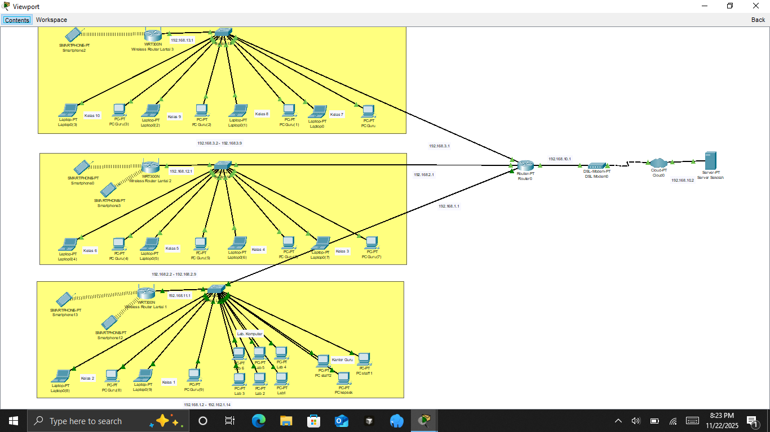
The school network topology utilizes three distinct subnets. Floor 3 (192.168.3.0–192.168.3.255), Floor 2 (192.168.2.0–192.168.2.255), and Floor 1 (192.168.1.0–192.168.1.255), each connected to Main Router via dedicated interfaces (192.168.3.1, 192.168.2.1, and 192.168.1.1 respectively). Router facilitates inter-floor routing and links to the internet through a DSL modem at 192.168.10.1, while the design includes a computer lab and teacher office on Floor 1, wireless coverage for smartphones, and wired connections, collectively meeting the requirements for a multi-floor educational environment with segmented yet integrated connectivity.
The Office Topology
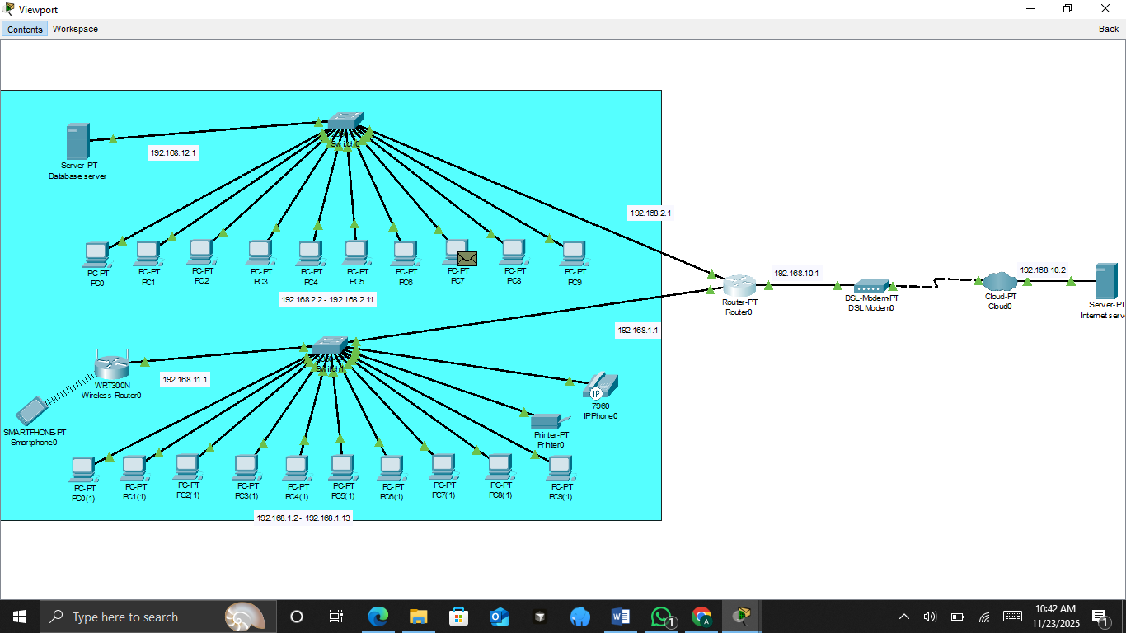
The office network topology is designed using two main subnets to segment employee devices and administrative services. The first subnet (192.168.2.0–192.168.2.255) connects 10 employee PCs and a database server through an access switch, while the second subnet (192.168.1.0–192.168.1.255) supports another group of PCs, a wireless router for smartphone connectivity, an IP phone, and a network printer. Both switches are linked to Main Router through separate interfaces (192.168.2.1 and 192.168.1.1), allowing efficient routing between departments while keeping traffic organized. Main Router then connects to a DSL modem at 192.168.10.1, which provides internet access through the cloud and links to an external web server. This layout delivers a structured, scalable, and easy-to-manage office environment with proper segmentation, centralized routing, wired and wireless access, and dedicated servers that meet the operational needs of a modern workplace.
- Cost Estimation
The School Topology
No | Device / Item | Quantity | Estimated Unit Price (IDR) | Total Price (IDR)
1. | Wireless Router | 3 units | 350.000 | 1.050.000
2. | Switch 24-Port | 3 units | 700.000 | 2.100.000
3. | Main Router | 1 unit | 1.200.000 | 1.200.000
4. | DSL Modem | 1 unit | 300.000 | 300.000
5. | Standard School Server | 1 unit | 6.000.000 | 6.000.000
6. | Desktop PCS | 19 units | 5.000.000 | 95.000.000
7. | Laptop Devices | 10 units | 7.000.000 | 70.000.000
8. | Smartphones | 5 units | 2.000.000 | 10.000.000
9. | UTP Cable+Connectors | 1 bundle | 450.000 | 450.000
10. | Installation Fee (Technician Labor) | 1 project | 2.000.000 | 2.000.000
 |  | Total |  | 186.900.000
The Office Topology
No | Device / Item | Quantity | Estimated Unit Price (IDR) | Total Price (IDR)
1. | Wireless Router | 1 unit | 350.000 | 350.000
2. | Switch 24-Port | 2 units | 700.000 | 1.400.000
3. | Main Router | 1 unit | 1.200.000 | 1.200.000
4. | DSL Modem | 1 unit | 300.000 | 300.000
5. | Office Server | 2 units | 6.000.000 | 12.000.000
6. | Desktop PCS | 20 units | 5.000.000 | 100.000.000
7. | Printer | 1 unit | 6.000.000 | 6.000.000
8. | IP Phone | 1 unit | 3.500.000 | 3.500.000
9. | Smartphones | 1 unit | 2.000.000 | 2.000.000
10. | UTP Cable+Connectors | 1 bundle | 450.000 | 450.000
11. | Installation Fee (Technician Labor) | 1 project | 2.000.000 | 2.000.000
 |  | Total |  | 129.200.000

CHAPTER IV

CLOSING

4.1. Conclusion
Based on the practicum results, both the school and office network designs successfully demonstrate how a star topology can be applied to create a stable, organized, and easy-to-manage network environment. In the school scenario, the use of wireless routers, switches, and a central router allows each floor and room to stay connected efficiently while supporting various devices such as PCs, laptops, smartphones, and the computer lab. Meanwhile, the office design also benefits from the same topology because it provides reliable access for employees and servers while allowing the network to be expanded easily when needed. Overall, the star topology proves to be the most suitable choice for both environments due to its simplicity, scalability, and ease of troubleshooting.

